1. Create a comparison table listing at least 3 key differences between WAN and LAN, and give one real-world example of each from apps or services you use daily (for example, IRCTC, Instagram, or Zomato).
answer
1. Comparison between WAN and LAN
WAN stands for Wide Area Network, while LAN stands for Local Area Network.
Basis | LAN (Local Area Network) | WAN (Wide Area Network)
Coverage | Covers a small area | Covers a large geographical area
Speed | Generally faster | Generally slower or has higher latency
Ownership | Usually owned by one person or organization | Often uses networks from multiple service providers
Cost | Less expensive to set up | More expensive to set up
Security | Easier to manage locally | Requires additional security measures
Example | Office Wi-Fi network | Internet connecting different cities
Real-world examples:
- LAN: A home Wi-Fi network connecting a laptop, mobile phone and printer.
- WAN: Flipkart uses internet and wide-area connectivity to connect customers in Ahmedabad with its services and infrastructure located in different cities.

2. Draw a simple network diagram using any drawing tool (or on paper and upload a photo) that shows how a user in Ahmedabad could connect to a Flipkart data center in Bangalore using a WAN, labeling the LAN and WAN segments clearly.
Answer
1. Create a comparison table listing at least 3 key differences between WAN and LAN, and give one real-world example of each from apps or services you use daily (for example, IRCTC, Instagram, or Zomato).
2. Draw a simple network diagram using any drawing tool (or on paper and upload a photo) that shows how a user in Ahmedabad could connect to a Flipkart data center in Bangalore using a WAN, labeling the LAN and WAN segments clearly.
3. Research and write a short summary (5-7 lines) explaining what MPLS is and how it improves data routing compared to traditional IP routing.
4. Observe the pre-configured MPLS network in the provided Packet Tracer or GNS3 file, and note down two routing behaviors that are different from standard IP routing.<br><br><em><strong>Hint:</strong> Look for how labels are used and how packets move between routers.</em>
5. List three specific benefits MPLS offers over traditional routing for companies running high-traffic apps like YouTube or BookMyShow, and briefly explain how each benefit helps in real-world scenarios.

3. Research and write a short summary (5-7 lines) explaining what MPLS is and how it improves data routing compared to traditional IP routing.
Answer
1. Create a comparison table listing at least 3 key differences between WAN and LAN, and give one real-world example of each from apps or services you use daily (for example, IRCTC, Instagram, or Zomato).
2. Draw a simple network diagram using any drawing tool (or on paper and upload a photo) that shows how a user in Ahmedabad could connect to a Flipkart data center in Bangalore using a WAN, labeling the LAN and WAN segments clearly.
3. Research and write a short summary (5-7 lines) explaining what MPLS is and how it improves data routing compared to traditional IP routing.
4. Observe the pre-configured MPLS network in the provided Packet Tracer or GNS3 file, and note down two routing behaviors that are different from standard IP routing.<br><br><em><strong>Hint:</strong> Look for how labels are used and how packets move between routers.</em>
5. List three specific benefits MPLS offers over traditional routing for companies running high-traffic apps like YouTube or BookMyShow, and briefly explain how each benefit helps in real-world scenarios.

4. Observe the pre-configured MPLS network in the provided Packet Tracer or GNS3 file, and note down two routing behaviors that are different from standard IP routing.<br><br><em><strong>Hint:</strong> Look for how labels are used and how packets move between routers.</em>
Answer
Two routing behaviours in an MPLS network
MPLS routing behaves differently from traditional IP routing in the following ways:
No. | MPLS routing behaviour | Traditional IP routing
1 | Routers use labels to forward packets. | Routers examine destination IP addresses.
2 | Intermediate routers swap the incoming label with a new outgoing label. | Each router independently checks its routing table to select the next hop.
Additional explanation:
- Label Push: The entry router adds an MPLS label to the packet.
- Label Swap: Intermediate routers replace the existing label with another label.
- Label Pop: The exit router removes the MPLS label before forwarding the packet outside the MPLS network. 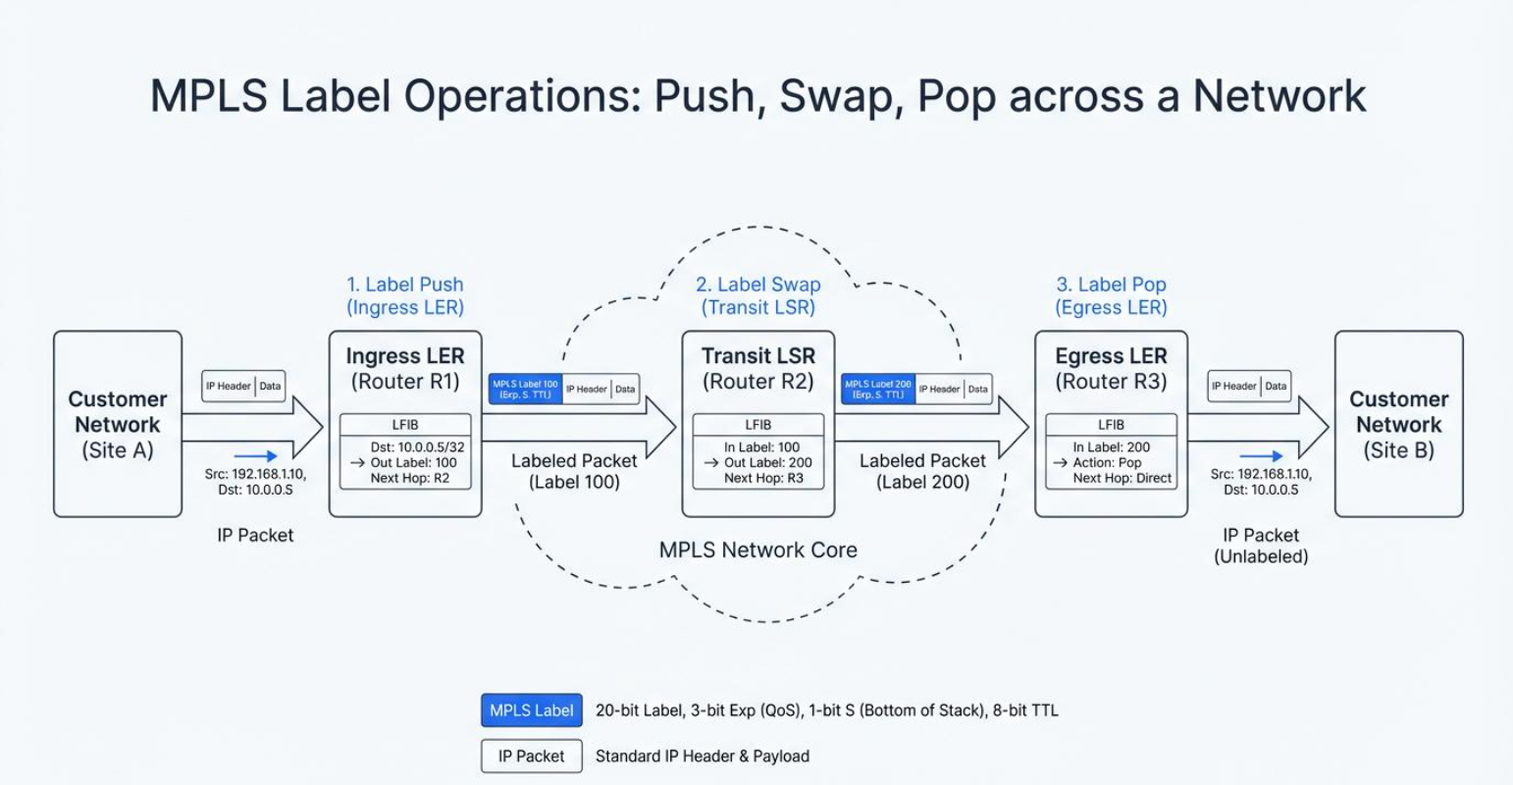

5. List three specific benefits MPLS offers over traditional routing for companies running high-traffic apps like YouTube or BookMyShow, and briefly explain how each benefit helps in real-world scenarios.
Answer
Three benefits of MPLS for companies
No. | Benefit | Real-world explanation
1 | Better traffic management | YouTube can prioritize video traffic to help reduce buffering and interruptions.
2 | Quality of Service (QoS) | BookMyShow can prioritize important booking transactions during high-demand ticket sales.
3 | Traffic Engineering | Companies can direct network traffic through suitable paths to avoid congested network links.
Conclusion:
MPLS improves network traffic management by using labels, supporting traffic prioritization and allowing better control over data paths. It is useful for companies that handle large amounts of data and need reliable network connectivity.
References
- RFC 3031 – MPLS Architecture – Official technical explanation of MPLS labels and packet forwarding.
- Cisco – MPLS Overview – MPLS label distribution and routing.
- Cisco – MPLS Quality of Service – Traffic prioritization and QoS.

